Project Planning Document – SmartSDLC

Date: 26 June 2025

Team ID: LTVIP2025TMID32004

Project Name: SmartSDLC: AI-Enhanced Software Development Lifecycle

**Product Backlog, Sprint Schedule, and Estimation**

|  |  |  |  |  |  |  |
| --- | --- | --- | --- | --- | --- | --- |
| Sprint | Epic | User Story Number | User Story / Task | Story Points | Priority | Team Members |
| Sprint-1 | Project Initialization | USN-1 | Set up Streamlit environment and base application structure | 2 | High | All |
| Sprint-1 | Watsonx Model Integration | USN-2 | Integrate IBM Watsonx Granite Model and test API response | 2 | High | Sandeep, Prudhvi,  Vallika |
| Sprint-2 | Requirements Classification | USN-3 | Upload PDF and classify into SDLC phases + user stories | 3 | High | Sandeep,  Bharath, Prudhvi |
| Sprint-2 | Code Generation Module | USN-4 | Generate code from prompt using LLM | 4 | High | Sandeep,  Prudhvi,  Vallika |
| Sprint-3 | Bug Fixer + Test Generator | USN-5 | Fix buggy code and auto-generate test cases | 5 | High | Sandeep,  Bharath,  Prudhvi |
| Sprint-3 | Code Summarization | USN-6 | Summarize code with explanation + use-case | 3 | Medium | Vallika,  Prudhvi,  Sandeep |
| Sprint-4 | Chat Assistant | USN-7 | Build conversational assistant for SDLC support | 3 | Medium | Sandeep,  Prudhvi,  Vallika |
| Sprint-4 | UI Enhancement + Deployment | USN-8 | Polish UI and deploy final application on Streamlit Cloud or VM | 4 | High | All |

**Project Tracker, Velocity & Burndown Chart**

|  |  |  |  |  |  |
| --- | --- | --- | --- | --- | --- |
| Sprint | Total Story Points | Sprint Start Date | Sprint End Date | Story Points Completed | Sprint Release Date |
| Sprint-1 | 4 | 01 July 2025 | 06 July 2025 | 4 | 06 July 2025 |
| Sprint-2 | 7 | 07 July 2025 | 12 July 2025 | 7 | 12 July 2025 |
| Sprint-3 | 8 | 13 July 2025 | 18 July 2025 | 7 | 18 July 2025 |
| Sprint-4 | 7 | 19 July 2025 | 24 July 2025 | 6 | 24 July 2025 |

Average Velocity = (4 + 7 + 7 + 6) / 4 = 6 story points per sprint

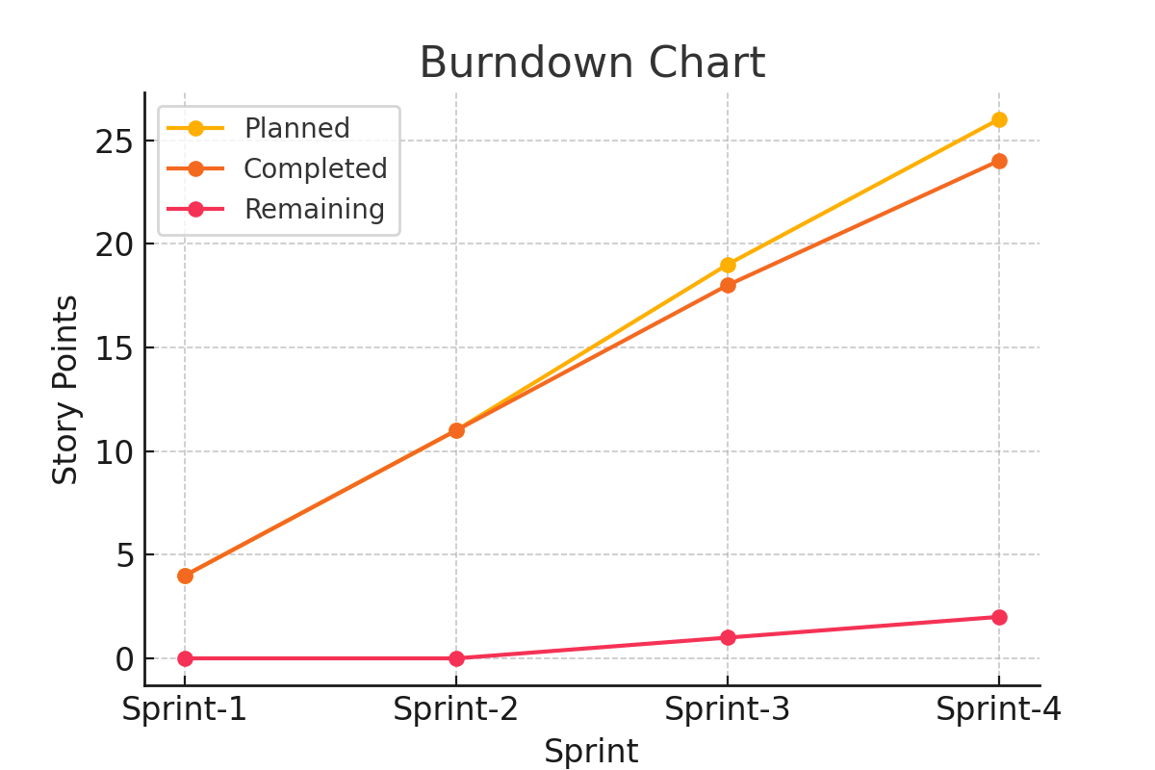

Figure: Sprint-wise Burndown Chart